MSBA 250 — Applied Business Analytics
University of the Pacific
Spring 2024
Assignment 6
Due: Wednesday May 1, 2024

Instructions:

This problem set has 3 questions. The full credit is 20.

Problem 1 (6 points):

Suppose that a car-rental agency offers insurance for a week that costs $100. A minor fender bender will cost $3,500, where a major accident might cost $16,000 in repairs. Without the insurance, you would be personally liable for any damages. What should you do? Clearly, there are two decision alternatives: take the insurance, or do not take the insurance. The uncertain consequences, or events that might occur, are that you would not be involved in an accident, that you in would be involved a fender bender, or that you would be involved in a major accident. Develop a payoff table for this situation. What decision should you make using each of the following strategies?

Decision | No Accident | Minor Accident | Major Accident
Insurance | -$100 | -$100 | -$100
No Insurance | $0 | -$3,500 | -$16,000

- Aggressive strategy (2 points): No insurance and no accident can save $100 compared to taking insurance.
- Conservative strategy (2 points): Insurance and pay no more than $100 even in a major accident.
- Opportunity-loss strategy (2 points): Insurance.

Minimax Regret Decision Calculation:

Action | No accident | Minor accident | Major accident | Maximum Opportunity Loss
Insurance | -$100 | $0 | $0 | -$100
No insurance | $0 | -$3,400 | -$15,900 | -$15,900

Problem 3 (7 points):

Please find the EXCEL file “Electricity”. Please focus on 2020 electricity emission. Please use Tableau to build a parameter and visualize it using a graph. The graph can be a bar chart, a histogram, or other charts. In the graph, please visualize both of the original 2020 electricity emission and the data when implementing the parameter (for each state). Please attach a screenshot of the graph and discuss the insights based on the graph.

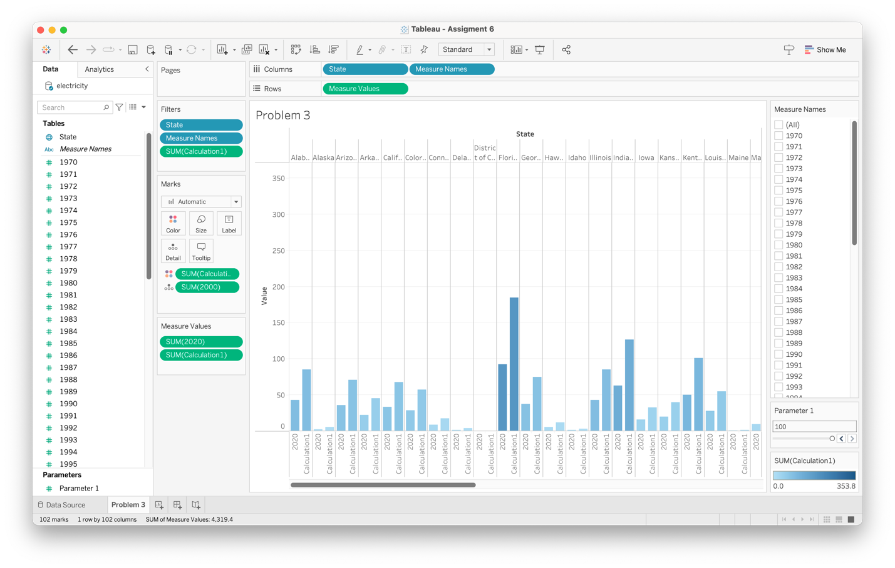
In the graph, Texas had the highest electricity emission of all states. The calculated emissions, Calculation1, are consistently higher than the original 2020 electricity emission. It can be adapted to visualized real-world impacts of policy changes or technological advancements.

Problem 3 (6 points):

Please find the EXCEL file “Investment”. Please use Tableau to run regressions to find the relationship between investment and revenue. Please identify the appropriate regression model and explain the reasons.

There a positive correlation between investment and revenue since the regression slop is positive. Not only the Power Model fit the best out of all models, but the p-value < 0.0001 also shows its significant.
